# User Interface Design

## Assignment Management System

### Course: Software design and analysis, SE606

Submitted to

Md. Nurul Ahad Tawhid,

Assistant Professor, IIT, DU

Submitted by

Tulshi Chandra Das-bsse0811

Maloy Kanti Sarker-bsse0834

# User Profile Model

# Instructor

### Demographics:

Age: 25-65

Gender: Male, Female

Background: Secondary, Higher Secondary, University

Cultural or ethnic background: Any

Holdings: Computer, Laptop, Smartphone

### Motivation:

i) Making an easy approach to manage assignment related notification and file online

ii) Creating a platform to communicate easily among students and instructors

iii) Making an easy online file sharing process

iv) Making assignment related tasks online

v) Providing a plagiarism checking procedure.

vi) Organizing assignment related tasks easily.

### Goal:

### Giving an easy approach to manage assignment related tasks and check plagiarism

|  |
| --- |
| Syntactic Knowledge Knowledge level: good  User needs to:  i) Know how to operate a computer, laptop or smartphone  ii) Know to use internet Semantic Knowledge Required language: English  User needs to be familiar with:  i) Basic knowledge cloud computing system and web services |
| Category freshman, Knowledgeable |

# Student

### Demographics:

Age: any

Gender: Male, Female

Background: Secondary, Higher Secondary, University

Cultural or ethnic background: Any

Holdings: Computer, Laptop, Smartphone

### Motivation:

i) Making an easy approach to manage assignment related notification and file online

ii) Creating a platform to communicate easily among students and instructors

iii) Making an easy online file submission process

iv) Showing distributed marks easily

### Goal:

### Giving an easy approach to manage assignment submission related tasks

### Syntactic Knowledge

Knowledge level: good

User needs to:

i) Know how to operate a computer, laptop or smartphone

ii) Know to use internet

### Semantic Knowledge

Required language: English

User needs to be familiar with:

i) Basic cloud computing system and online services

### Category

Freshman, Knowledgeable

# Design Model

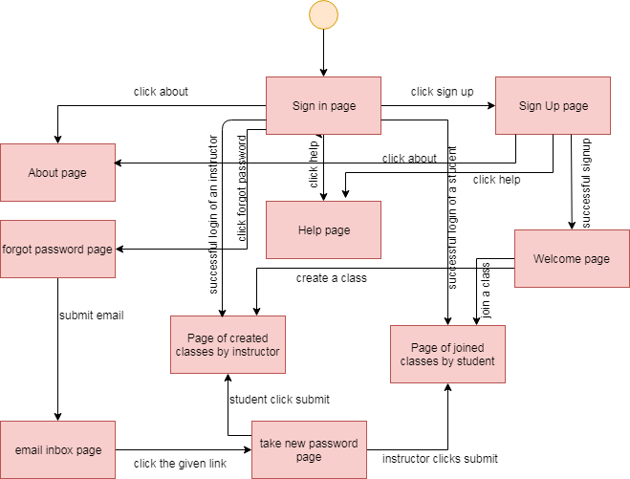

Figure 1: User module interface design

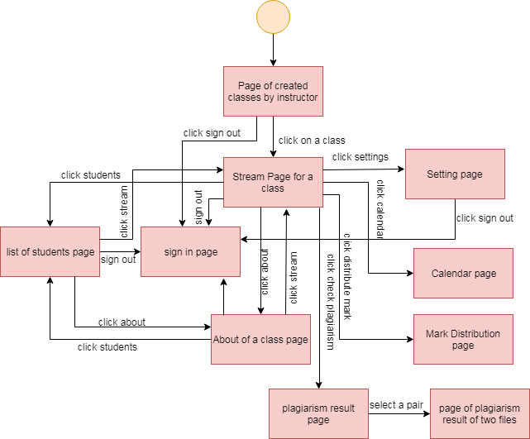

Figure 2: Instructor module of interface design

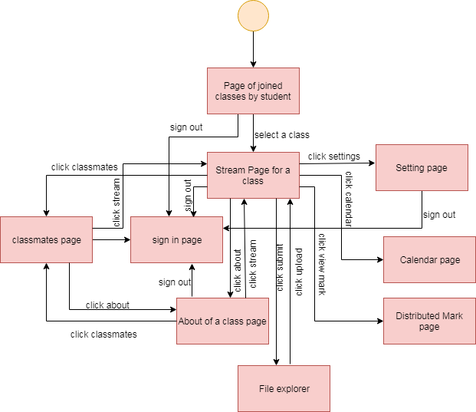

Figure 3: Student module of Interface design

# Individual User Interface design



Figure : User interface of sign in



Figure : User interface of sign up

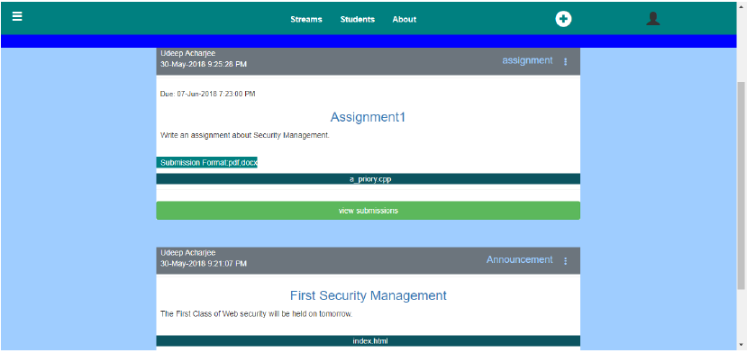

Figure : User interface of Stream page of instructor